**TECHNICAL REQUIRENMENTS FOR**

**INVESTMENT PLATFORM FOR CO-INVESTING INTO REAL ESTATE**

**General Information**

1. Team**:** Laplace
2. Project Description:

Real-Invest – a platform that allows investors to pool resources and co-invest into real estate properties.

1. Technical Requirements

* Cross platform mobile app
* Listing of investment opportunities
* Investor portfolio overview
* A scoring system for investment evaluation

**System analysis of business processes**

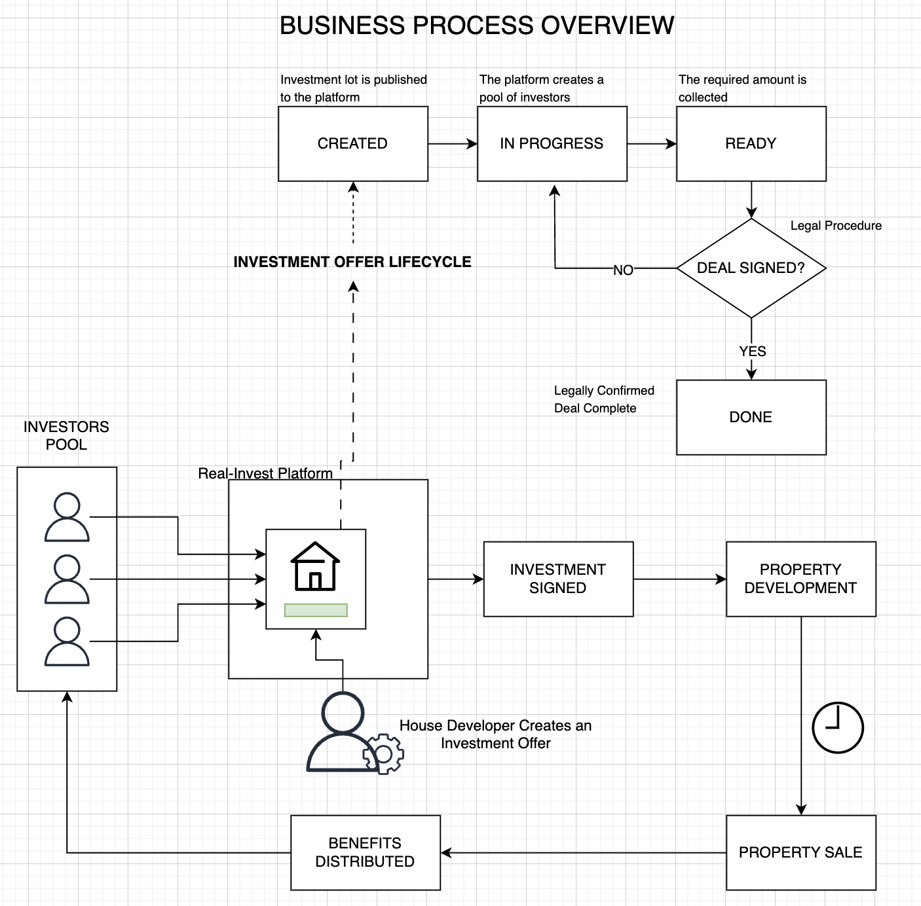

**Functional Requirements for the Mobile Application**

3 main windows

* 1. Investment opportunities listing. Provides concise overview of the apartments ready for investing.
  2. Detailed description of an investment opportunity.
  3. Profile window. Illustrates commitments from the investor.

**Technical architecture of the project**

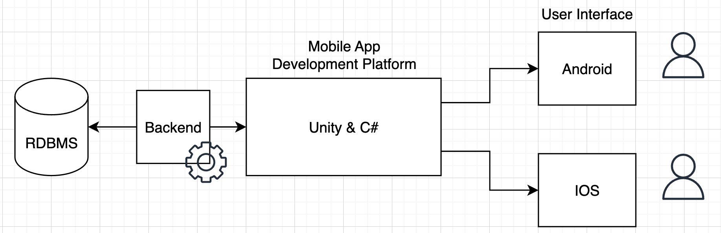

**Scoring System**

Initially, based on open data the algorithm uses quotative metrics from maps and open weather applications.

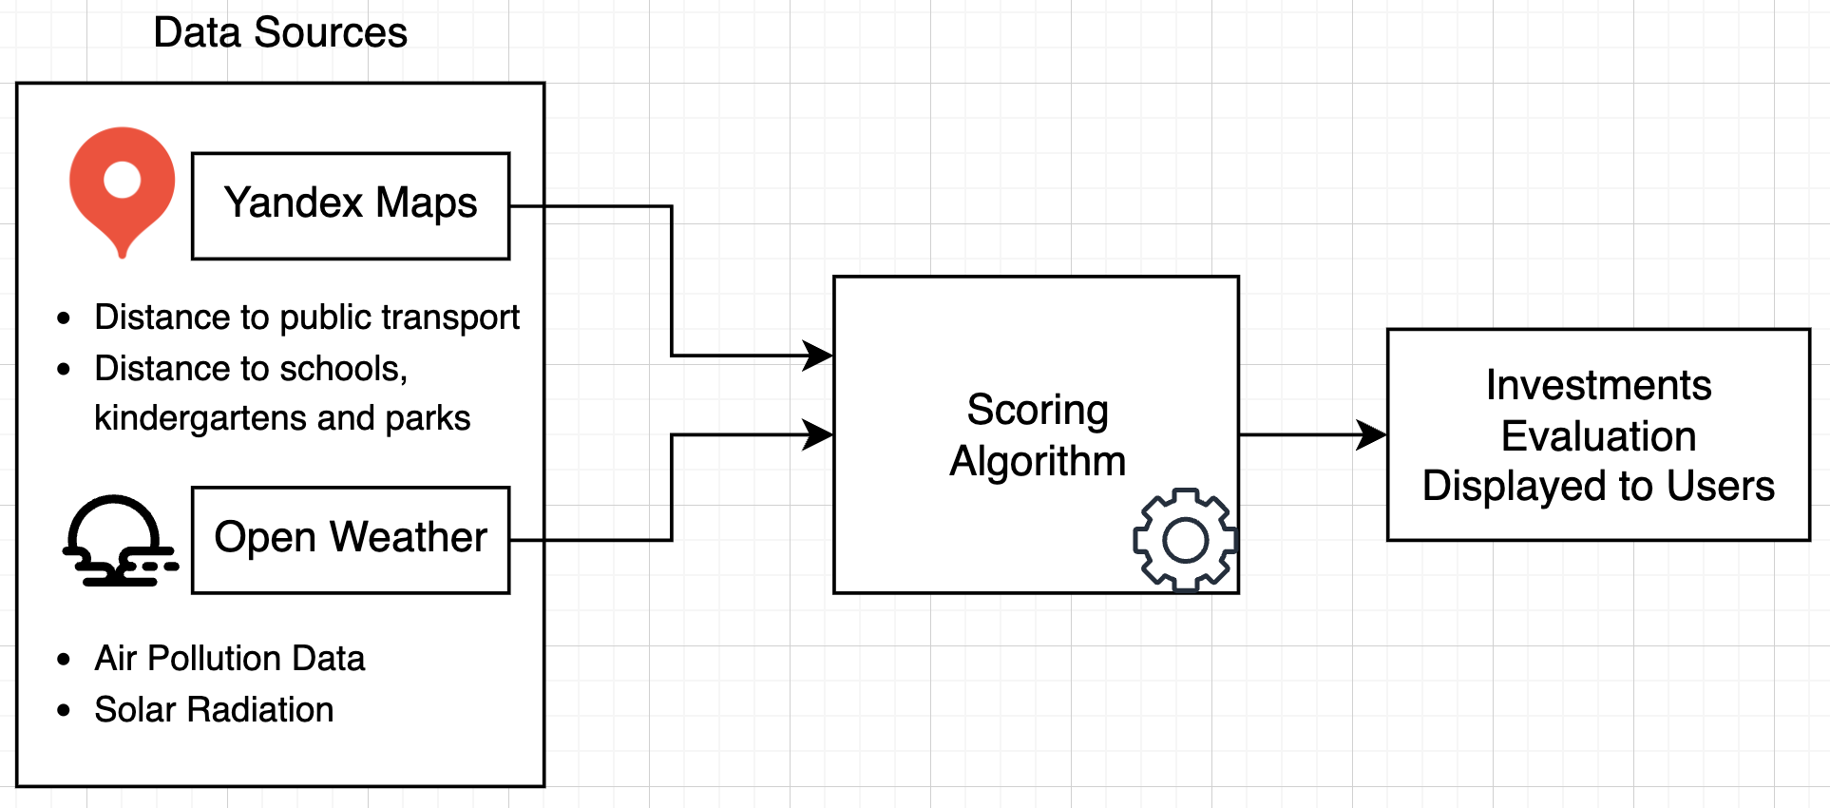

**Additional Information**

1. Application uses MVC architecture pattern
2. Application takes advantage of Dependency Injection (DI) techniques and follows SOLID principles.